PS6

Prateek Kumar

20 October 2018

set.seed(1000)  
indoor<- sample(c("A","B","C","D"),prob=c(5,8,25,6),size=200,replace=T)  
outdoor <-sample(c("A","B","C","D"),prob=c(5,20,3,6),size=200,replace=T)  
tab1 <- table(indoor,outdoor) #cross-tabulations of each pair of responses  
tab2 <- table(c(indoor,outdoor),rep(c("I","O"),each=200)) #what responses were given for indoor and outdoor across the four options  
  
row.names(tab1) <- c('clowns','horses','chocolate fountain','magician') #Changing the row and column names  
colnames(tab1) <- c('clowns','horses','chocolate fountain','magician')  
row.names(tab2) <- c('clowns','horses','chocolate fountain','magician')  
addmargins(tab1)

## outdoor  
## indoor clowns horses chocolate fountain magician Sum  
## clowns 4 11 3 5 23  
## horses 9 23 1 10 43  
## chocolate fountain 19 59 10 19 107  
## magician 5 12 2 8 27  
## Sum 37 105 16 42 200

tab2

##   
## I O  
## clowns 23 37  
## horses 43 105  
## chocolate fountain 107 16  
## magician 27 42

Here we have two tables: tab1 and tab2, tab1 compares the children indoor response across various outdoor responses so its a cross tabulation of each pair of responses and tab2 gives us the details as what responses were given for both indoor and outdoor across the four options.

# Determine whether responses to indoor preference influenced individuals response to outdoor preference

#chisq.test(tab2[,1],p = tab2[,2],rescale.p = T)  
#install.packages("corrplot")  
library(corrplot)

## corrplot 0.84 loaded

library(BayesFactor)

## Loading required package: coda

## Loading required package: Matrix

## ************  
## Welcome to BayesFactor 0.9.12-4.2. If you have questions, please contact Richard Morey (richarddmorey@gmail.com).  
##   
## Type BFManual() to open the manual.  
## ************

ct_t1 <- chisq.test(tab1)

## Warning in chisq.test(tab1): Chi-squared approximation may be incorrect

ct_t1 #Chi-squared test on tab1

##   
## Pearson's Chi-squared test  
##   
## data: tab1  
## X-squared = 5.0836, df = 9, p-value = 0.827

bf_t1 <- contingencyTableBF(tab1, sampleType = 'indepMulti', fixedMargin = 'cols')   
bf_t1 #bayes factor contingency table tests for tab1

## Bayes factor analysis  
## --------------  
## [1] Non-indep. (a=1) : 0.000346898 ±0%  
##   
## Against denominator:  
## Null, independence, a = 1   
## ---  
## Bayes factor type: BFcontingencyTable, independent multinomial

bf_t1@bayesFactor$bf #bayes factor value

## [1] -7.96648

corrplot(ct_t1$residuals, is.cor = F)

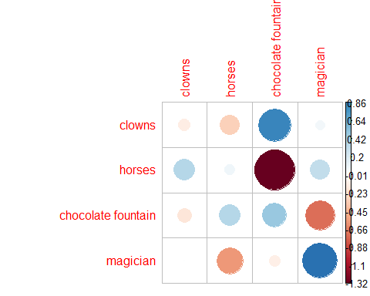

Inorder to determine if responses to indoor preference influenced individuals response to outdoor preference we use tab1 because its the cross tabulation of each pair of responses.

Here I performed both the chi-squared tests and bayes factor contingency table tests for tab1.

Null hypothesis(H0): The responses to indoor preference do not influence the individual response to outdoor preference. Alternative hypothesis(H1): The responses to indoor preference influence the individual response to outdoor preference.

Chi-squared test: * We see that the p-value = 0.827 which is much greater than 0.05, * Also we here have 9 degrees of freedom[(row-1)(column-1)] for which Chi-square (??-squared) value should be 16.91897760(from the table) but here we get X-squared = 5.0836 which is less than the expected value

So this indicates weak evidence against the Null hypothesis(H0), so we fail to reject the Null hypothesis

Bayes factor contingency table * We get the bayes factor value as -7.966 which is smaller than 0.00667 So this is also a very strong evidence for Null hypothesis.

And hence we see from the above results that both the Chi-squared test and bayes factor fail to reject the Null hypothesis so we can conclude that “the responses to indoor preference do not influence the individual response to outdoor preference”.

# Determine whether indoor and outdoor preferences were the same

ct_t2 <- chisq.test(tab2)  
ct_t2 #Chi-squared test on tab2

##   
## Pearson's Chi-squared test  
##   
## data: tab2  
## X-squared = 99.826, df = 3, p-value < 2.2e-16

bf_t2 <- contingencyTableBF(tab2, sampleType = 'indepMulti', fixedMargin = 'cols')  
bf_t2 #bayes factor contingency table tests for tab2

## Bayes factor analysis  
## --------------  
## [1] Non-indep. (a=1) : 1.21942e+21 ±0%  
##   
## Against denominator:  
## Null, independence, a = 1   
## ---  
## Bayes factor type: BFcontingencyTable, independent multinomial

bf_t2@bayesFactor$bf #bayes factor value

## [1] 48.55266

corrplot(ct_t2$residuals, is.cor = F)

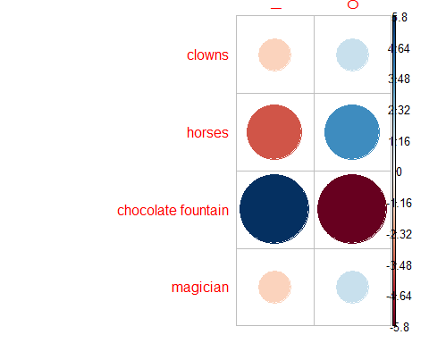

#Indoor high association for chocolate fountain(strong positive association) & high association for outdoor and horses  
#There is repulsion between outdoor and chocolate fountain